<!doctype html>

<html lang="en">

  <head>

    <!-- Required meta tags -->

    <meta charset="utf-8">

    <meta name="viewport" content="width=device-width, initial-scale=1">

    <meta http-equiv="X-UA-Compatible" content="IE=edge">

    <!-- icon CDN -->

    <link rel="stylesheet" href="https://cdnjs.cloudflare.com/ajax/libs/font-awesome/4.7.0/css/font-awesome.css" integrity="sha512-5A8nwdMOWrSz20fDsjczgUidUBR8liPYU+WymTZP1lmY9G6Oc7HlZv156XqnsgNUzTyMefFTcsFH/tnJE/+xBg==" crossorigin="anonymous" referrerpolicy="no-referrer" />

    <!-- Bootstrap CSS -->

    <link href="https://cdn.jsdelivr.net/npm/bootstrap@5.0.2/dist/css/bootstrap.min.css" rel="stylesheet" integrity="sha384-EVSTQN3/azprG1Anm3QDgpJLIm9Nao0Yz1ztcQTwFspd3yD65VohhpuuCOmLASjC" crossorigin="anonymous">

    <!-- Main.css -->

    <link rel="stylesheet" href="css/main.css">

    <title>Simple House</title>

  </head>

  <body>

    <nav class="navbar navbar-expand-lg navbar-light bg-light">

      <div class="container-fluid mt-auto">

        <a class="navbar-brand" href="#">

          <img src="image/logo.png" width="60" height="60" alt="">

        </a>

        <a class="navbar-brand text-white fontsize-logo" href="#">Simple House</a>

        <button class="navbar-toggler" type="button" data-bs-toggle="collapse" data-bs-target="#navbarSupportedContent" aria-controls="navbarSupportedContent" aria-expanded="false" aria-label="Toggle navigation">

          <span class="navbar-toggler-icon"></span>

        </button>

        <div class="collapse navbar-collapse justify-content-end" id="navbarSupportedContent">

          <ul class="navbar-nav mb-2 mb-lg-0">

            <li class="nav-item">

              <a class="nav-link active text-white hover-nav p-4" aria-current="page" href="#">Home</a>

            </li>

            <li class="nav-item">

              <a class="nav-link active text-white hover-nav p-4" aria-current="page" href="#">About</a>

            </li>

            <li class="nav-item">

              <a class="nav-link active text-white hover-nav p-4" aria-current="page" href="#">Contact</a>

            </li>

    </nav>

    <main>

    <div class="main-top">

      <div class="px-4 pt-5 my-5 text-center border-bottom overflow-hidden">

        <h1 class="display-4 fw-800">Welcome to Simple House</h1>

        <div class="col-lg-6 mx-auto">

          <p class="lead mb-6 text-secondary fs-20">Total 3 HTML pages are included in this template. Header image has been parallax effect. <br> you can Feel free to download, edit and use this TemplateMo layout for <br> your commercial or non commercial websites.</p>

        </div>

      </div>

    </div>

    <!-- Middle Main -->

    <div class="main-mid d-flex justify-content-center">

      <div class="buttons-nav">

      <button type="button" class="btn btn-outline-success px-4 mt-2">Pizza</button>

      <button type="button" class="btn btn-outline-success px-4 mt-2">Salad</button>

      <button type="button" class="btn btn-outline-success px-4 mt-2">Noodles</button>

     </div>

     </div>

     <div class="container mt-4 aligniment">

      <div class="container">

        <div class="row">

          <div class="col">

            <div class="card border-0" style="width: 18rem;">

              <img src="image/fruitsalad.jpg" class="card-img-top" alt="..." height="300px">

              <div class="card-body">

                <h5 class="card-title">Fusce dictum finibus</h5>

                <p class="card-text">Some quick example text to build on the card title and make up the bulk of the card's content.</p>

                <a href="#" class="text-success text-decoration-none price">$45/$55</a>

              </div>

            </div>

          </div>

          <div class="col">

            <div class="card border-0" style="width: 18rem;">

              <img src="image/pizza.jpg" class="card-img-top" alt="..." height="300px">

              <div class="card-body">

                <h5 class="card-title">Aliquam sagittis</h5>

                <p class="card-text">Some quick example text to build on the card title and make up the bulk of the card's content.</p>

                <a href="#" class="text-success text-decoration-none price">$65/$70</a>

              </div>

            </div>

          </div>

          <div class="col">

            <div class="card border-0" style="width: 18rem;">

              <img src="image/gralicbread.jpg" class="card-img-top" alt="..." height="300px">

              <div class="card-body">

                <h5 class="card-title">Sed varius turpis</h5>

                <p class="card-text">Some quick example text to build on the card title and make up the bulk of the card's content.</p>

                <a href="#" class="text-success text-decoration-none price">$30.50</a>

              </div>

            </div>

          </div>

          <div class="col">

            <div class="card border-0" style="width: 18rem;">

              <img src="image/saggetti.jpg" class="card-img-top" alt="..." height="300px">

              <div class="card-body">

                <h5 class="card-title">Aliquam sagittis</h5>

                <p class="card-text">Some quick example text to build on the card title and make up the bulk of the card's content.</p>

                <a href="#" class="text-success text-decoration-none price">$25.50</a>

              </div>

            </div>

          </div>

        </div>

        <div class="row mt-5">

          <div class="col">

            <div class="card border-0" style="width: 18rem;">

              <img src="image/nuggets.jpg" class="card-img-top" alt="..." height="300px">

              <div class="card-body">

                <h5 class="card-title">Maecenas eget justo</h5>

                <p class="card-text">Some quick example text to build on the card title and make up the bulk of the card's content.</p>

                <a href="#" class="text-success text-decoration-none price">$80.25</a>

              </div>

            </div>

          </div>

          <div class="col">

            <div class="card border-0" style="width: 18rem;">

              <img src="image/Fruit_Sandwich.jpg" class="card-img-top" alt="..." height="300px">

              <div class="card-body">

                <h5 class="card-title">Quisque et felis eros</h5>

                <p class="card-text">Some quick example text to build on the card title and make up the bulk of the card's content.</p>

                <a href="#" class="text-success text-decoration-none price">$20/$40/$60</a>

              </div>

            </div>

          </div>

          <div class="col">

            <div class="card border-0" style="width: 18rem;">

              <img src="image/vegetable-salad.jpg" class="card-img-top" alt="..." height="300px">

              <div class="card-body">

                <h5 class="card-title">Sed ultricies dui</h5>

                <p class="card-text">Some quick example text to build on the card title and make up the bulk of the card's content.</p>

                <a href="#" class="text-success text-decoration-none price">$94</a>

              </div>

            </div>

          </div>

          <div class="col">

            <div class="card border-0" style="width: 18rem;">

              <img src="image/momos.jpg" class="card-img-top" alt="..." height="300px">

              <div class="card-body">

                <h5 class="card-title">Donec porta consequat</h5>

                <p class="card-text">Some quick example text to build on the card title and make up the bulk of the card's content.</p>

                <a href="#" class="text-success text-decoration-none price">$15</a>

              </div>

            </div>

          </div>

        </div>

      </div>

    </div>

    <div class="container mt-5">

      <div class="card mb-3 border-0">

        <div class="row no-gutters">

          <div class="col-md-6">

            <img src="image/avacado.jpg" class="card-img" alt="...">

          </div>

          <div class="col-md-4">

            <div class="card-body">

              <h5 class="card-title">Meacenas nulla neque</h5>

              <p class="card-text">This is a wider card with supporting text below as a natural lead-in to additional content. This content is a little bit longer. sing a combination of grid and utility classes, cards can be made horizontal in a mobile-friendly and responsive way. In the example below, we remove the grid gutters with .no-gutters and use .col-md-* classes to make the card horizontal at the md breakpoint. Further</p>

              <button type="button" class="btn btn-outline-secondary mt-4">Read More</button>

            </div>

          </div>

        </div>

      </div>

    </div>

  </main>

  <footer class="container mt-5 bg-light p-3 d-flex justify-content-center">

    <p>Copyright  &copy; 2020 Simple House |<a href="#">Desgined</a> : <a href="#">Adeeb Shah</a></p>

  </footer>

  <!-- js SCripts -->

  <script src="https://code.jquery.com/jquery-3.4.1.slim.min.js" integrity="sha384-J6qa4849blE2+poT4WnyKhv5vZF5SrPo0iEjwBvKU7imGFAV0wwj1yYfoRSJoZ+n" crossorigin="anonymous"></script>

  <script src="https://cdn.jsdelivr.net/npm/popper.js@1.16.0/dist/umd/popper.min.js" integrity="sha384-Q6E9RHvbIyZFJoft+2mJbHaEWldlvI9IOYy5n3zV9zzTtmI3UksdQRVvoxMfooAo" crossorigin="anonymous"></script>

  <script src="https://stackpath.bootstrapcdn.com/bootstrap/4.4.1/js/bootstrap.min.js" integrity="sha384-wfSDF2E50Y2D1uUdj0O3uMBJnjuUD4Ih7YwaYd1iqfktj0Uod8GCExl3Og8ifwB6" crossorigin="anonymous"></script>

  </body>

</html>

**Main.css –**

.navbar{

    background-image: url('background.jpg');

    background-size: cover;

    height: 500px;

  }

  .hover-nav:hover{

    border-bottom: 1px solid white;

  }

  .fontsize-logo{

    font-size: 50px;

  }

  button{

    border-radius: 0px !important;

    margin-right: 10px;

  }

  .card{

    margin-top: 20px;

  }

  .price{

    font-size: 20px;

  }

  @media (max-width: 600px){

    *{

      margin-right: 0;

    }

    .fontsize-logo{

        font-size: 30px;

      }

      .buttons-nav{

          display: flex;

          flex-direction: column;

      }

      .aligniment{

          padding-left:80px;

      }

  }

**Output –**

**Desktop-**

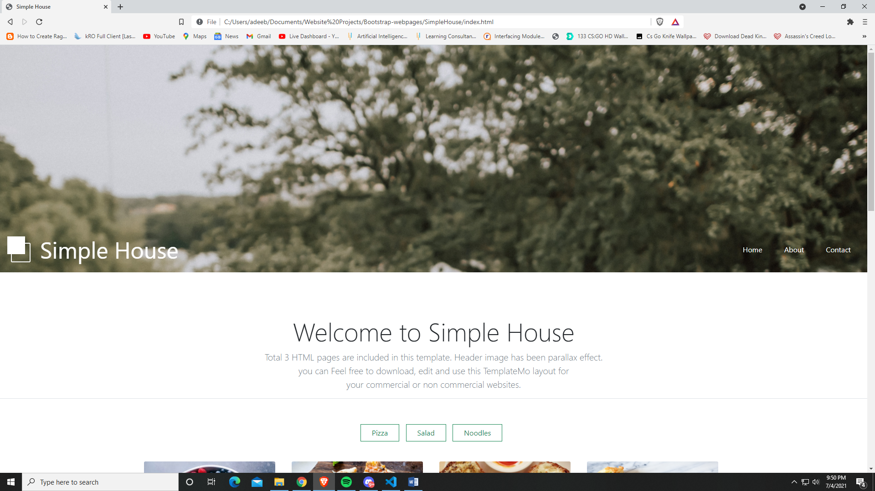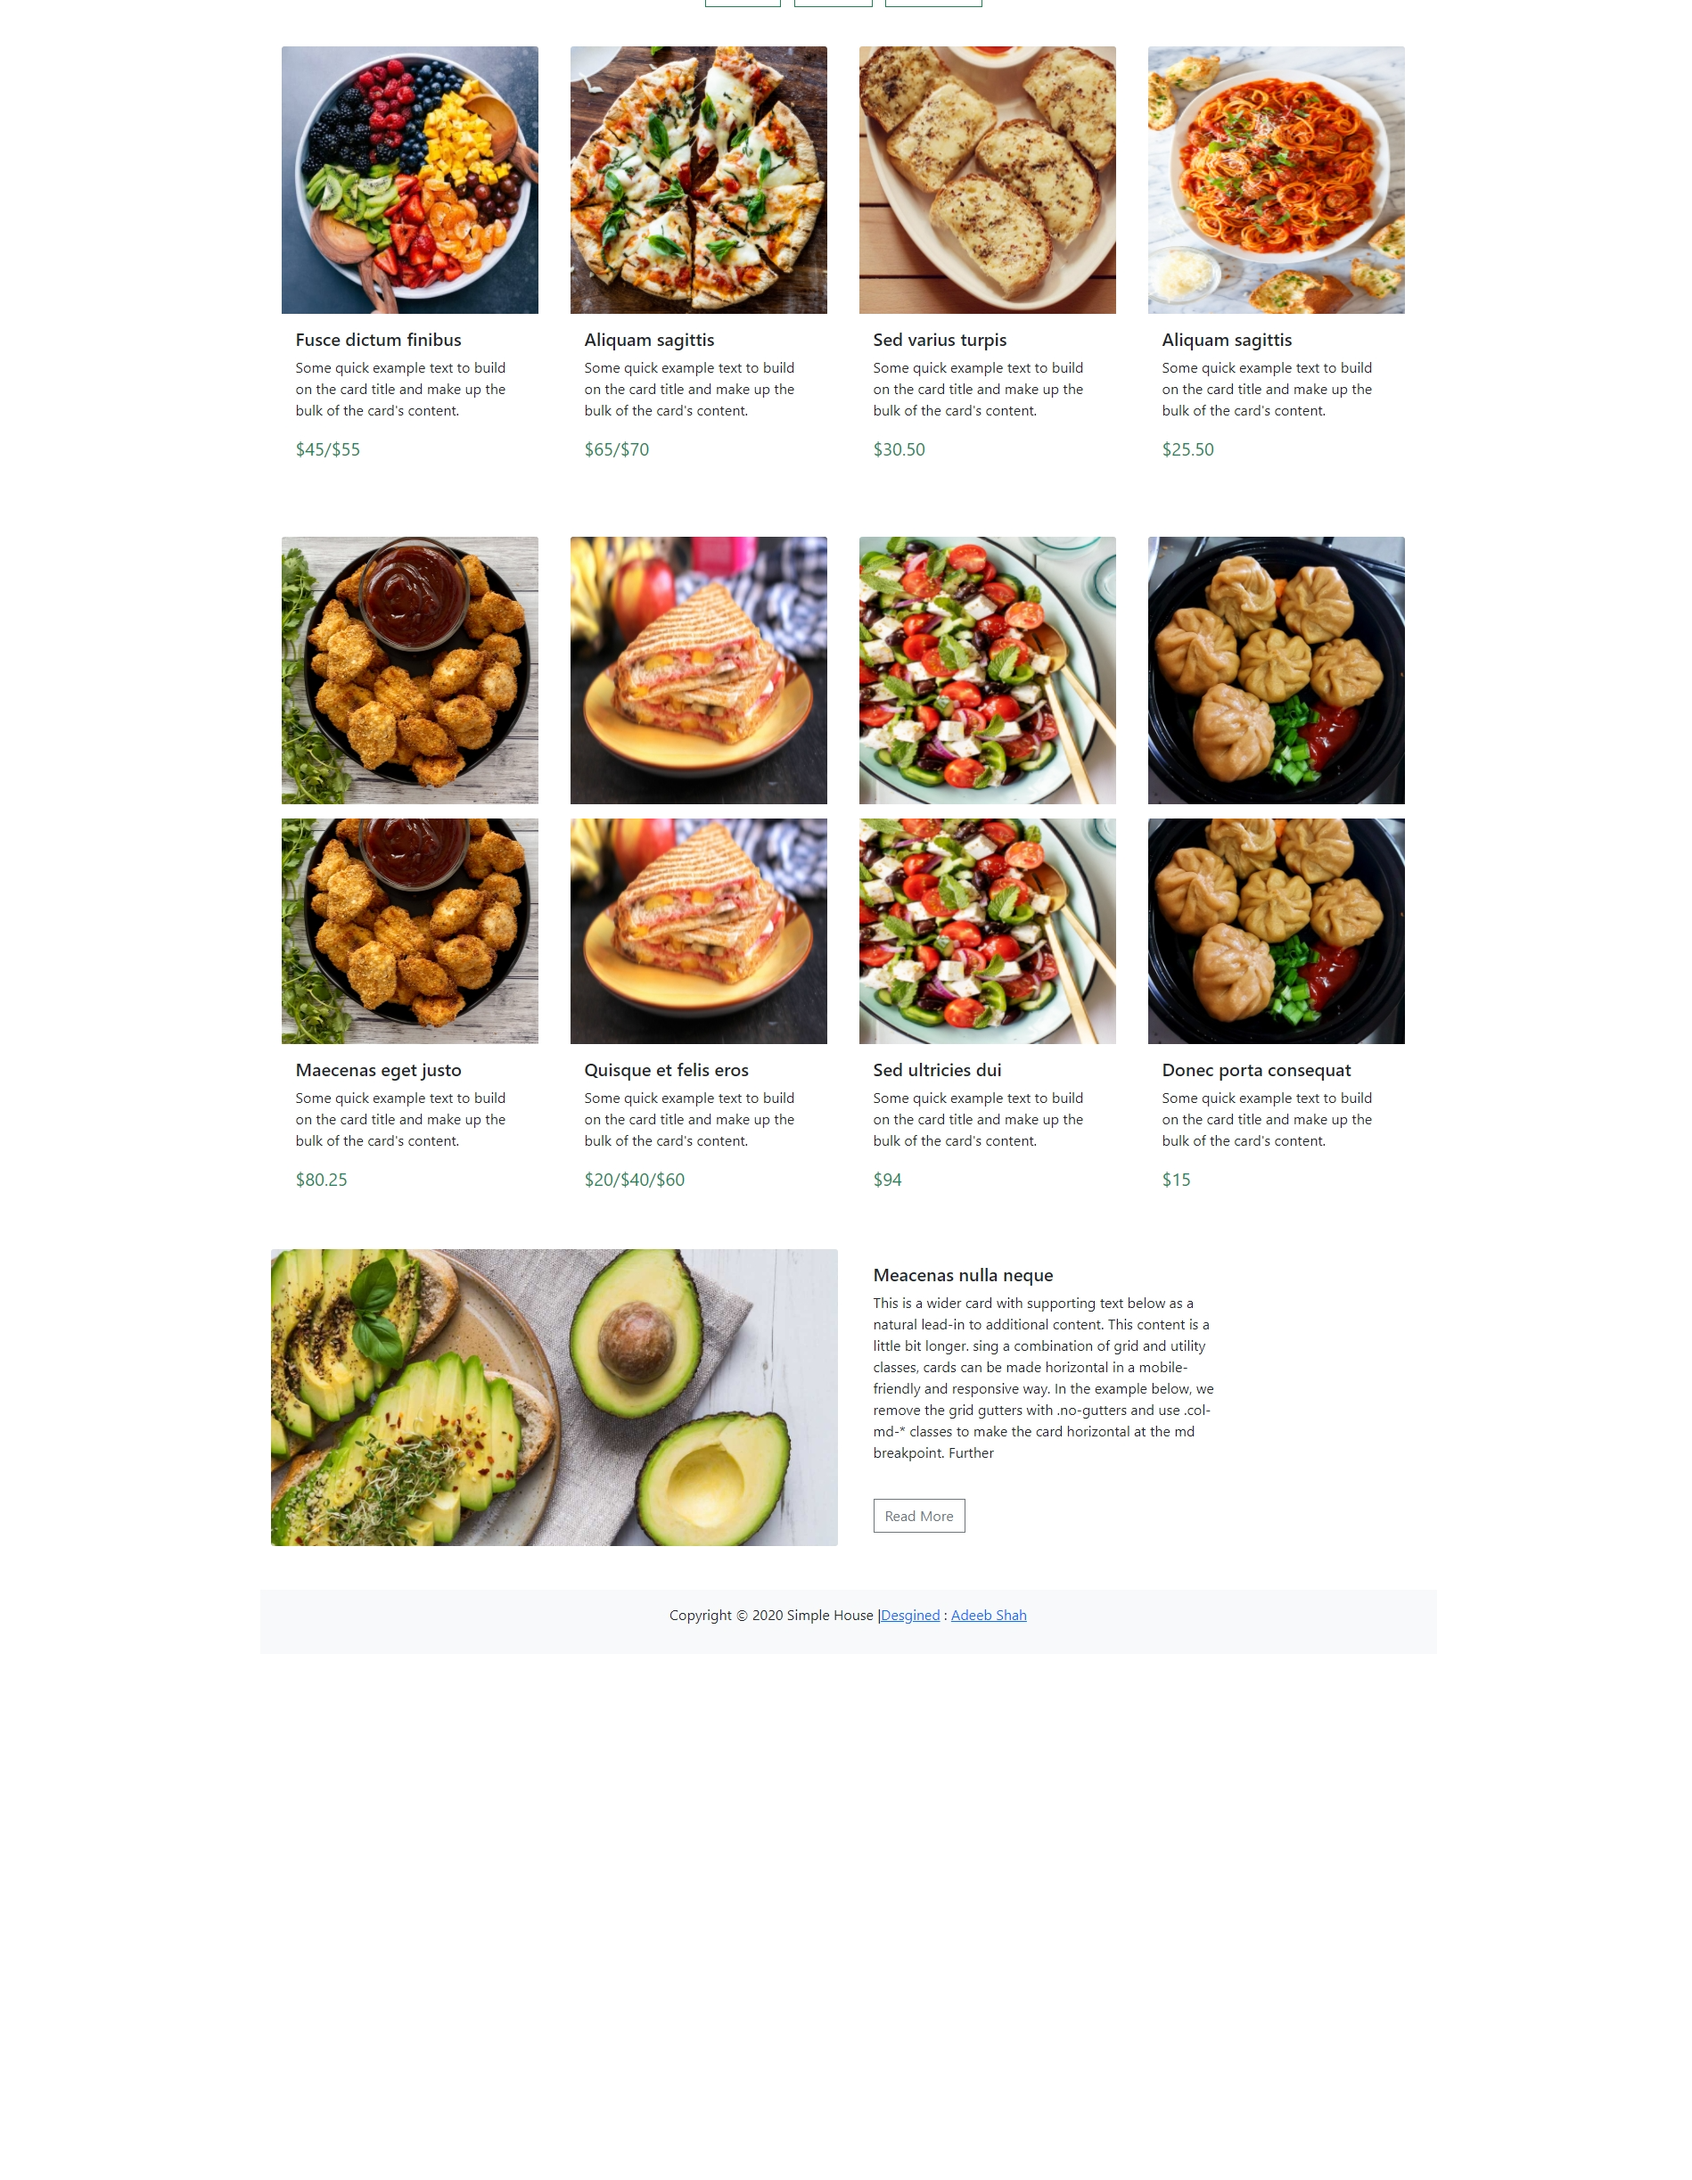

**Tablet –**

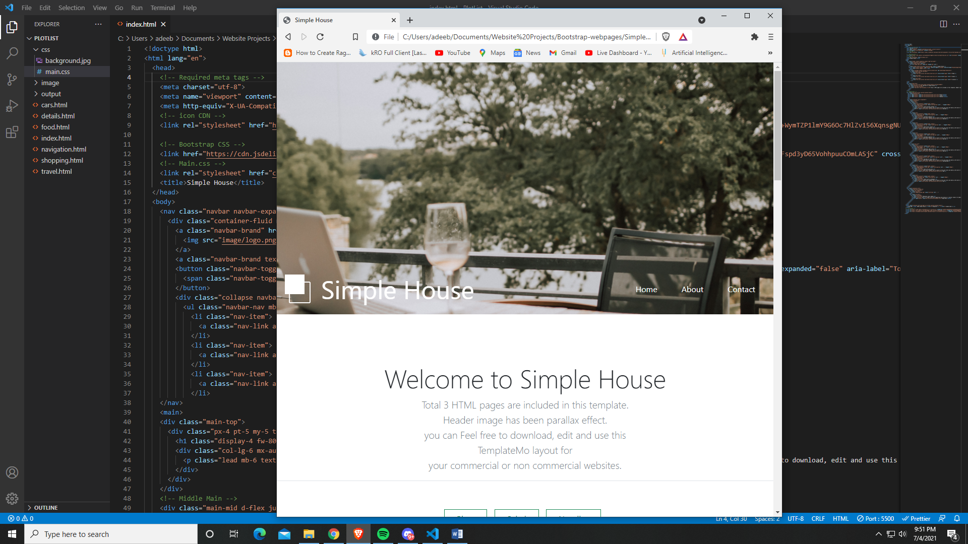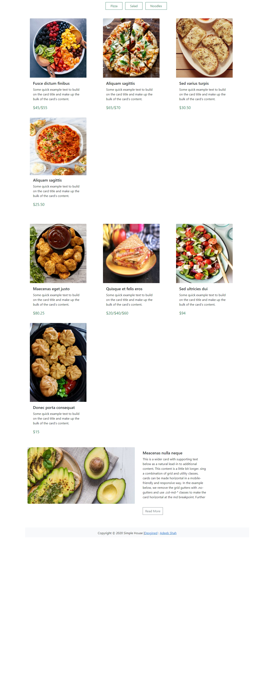

**Moblie –**

